BATTERY & FLASHLIGHT *(WB_GAMEMENU & BP_THIRDPERSON)*

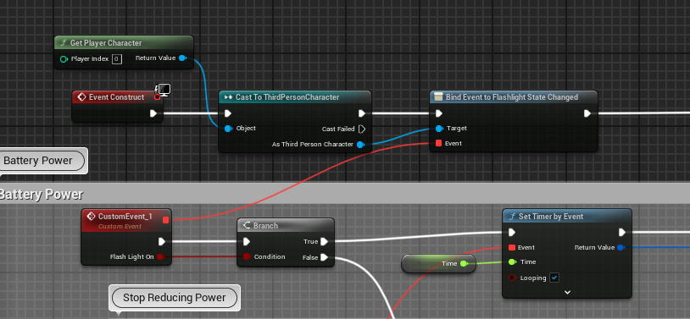

Detecting Flashlight is On or not, event Flashlight state Changed dipanggil di BPThirdPerson.

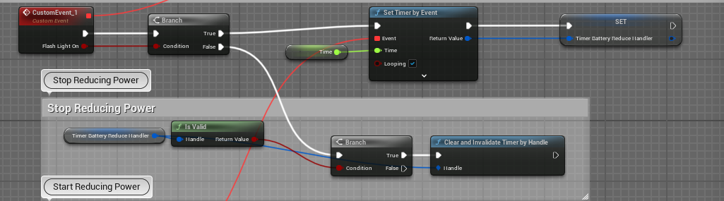

If flashlight on, it called timer function that set to every 1 second to reduce the power of battery, and then saving the reference to variable so whenever stop reducing power it called the reference to stop the timer that running.

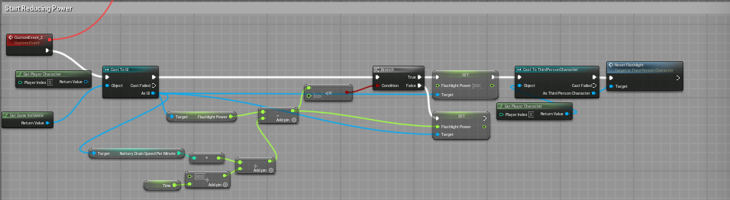

Reducing power dipanggil setiap 1 detik, the variable of flashlight power saved on GI, with mathematical formula so the reduce speed is not depend on user FPS(frame per second).

Releasing (at Rescue the Other objective)

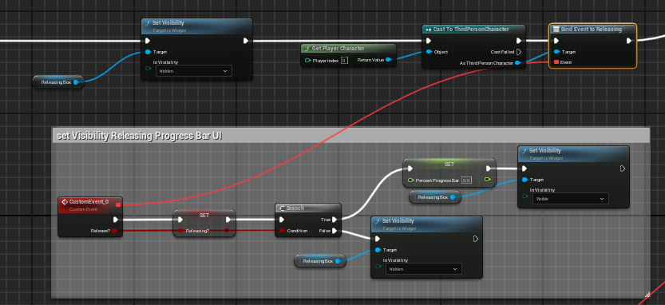

Di WB_GameMenu listen to event releasing on ThirdPersonCharacter Event Dispatcher yaitu ‘Releasing` dan mempassingkan 1 parameter Boolean yaitu ‘Release?’.

If true then reset value progressBar to 0 and set visibility to visible.

If false then set progress bar visibility to hidden

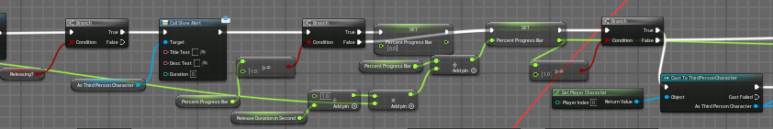

Dipanggil setiap event tick, untuk cek apakah sedang releasing atau tidak. Berfungsi sebagai update progress bar value dengan rumus matematika sehingga kecepatan progress bar tidak bergantung pada FPS (frame per second) user.

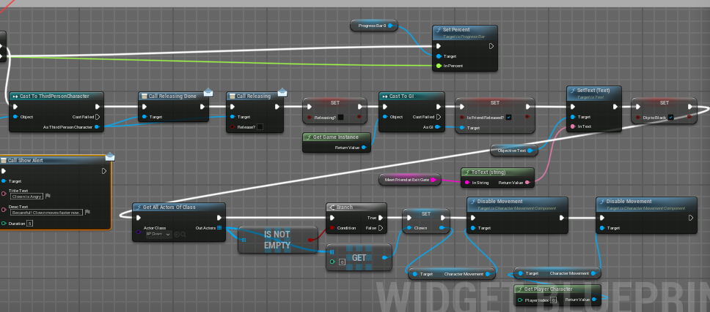

if releasing value already full (100) then it call event dispatcher named ‘Releasing Done’. And then disable all movement on clown and third person character.

Objectives Text (called on every inventory updated)

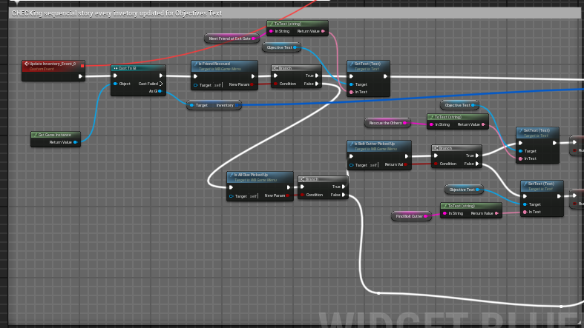

To update the objective text, each condition return different result objectives text.

**Cutscene** (WB_Cutscene)

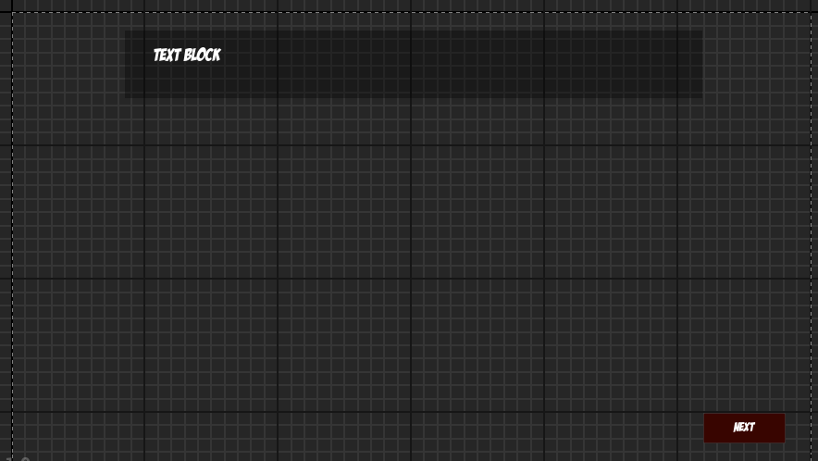



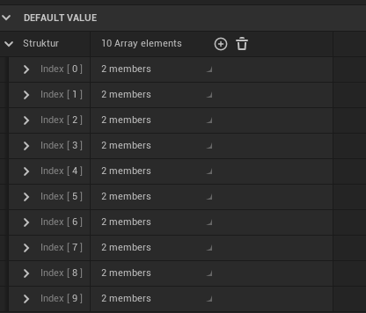

all text and images saved to 1 variable named struktur.

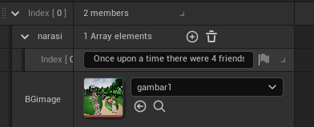

For example scene 1.

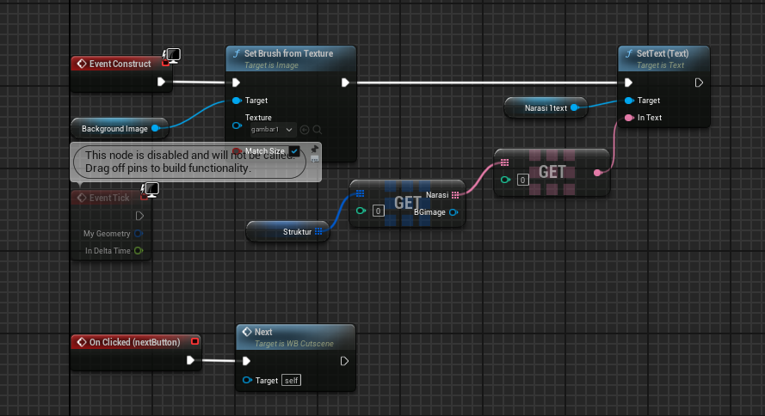

On construct it set background image to gambar1 and set text to narasi text index 0 on variable struktur index 0.

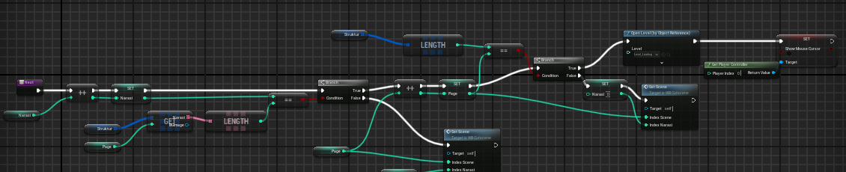

This is inside ‘next’ function.

**Credit Scene** (WB_GameOver)

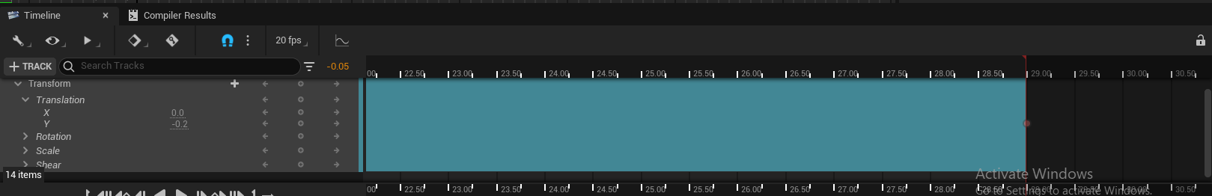

Using Widget’s Animation to animate from bottom to top using y axis

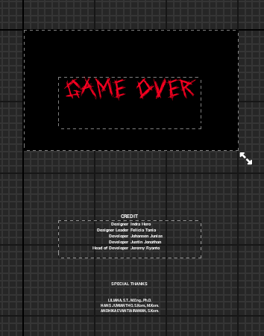

All these text scoped to 1 verticalbox.

Door (BP_Door)

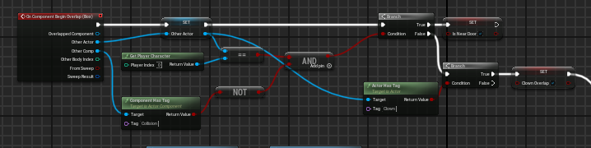

Cek actor overlap, dengan character atau badut

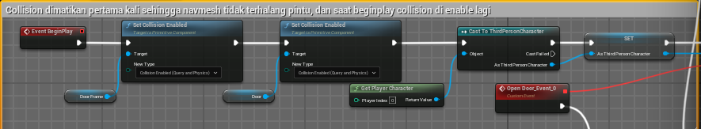

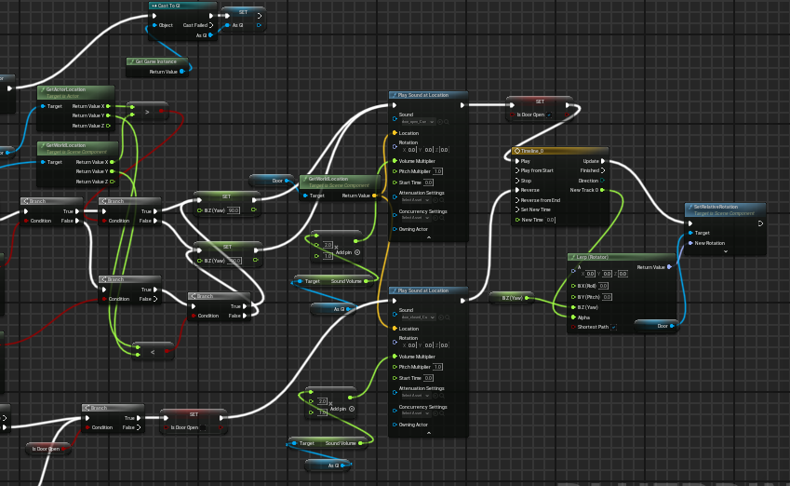

Membuat pintu terbuka searah dari arah player.